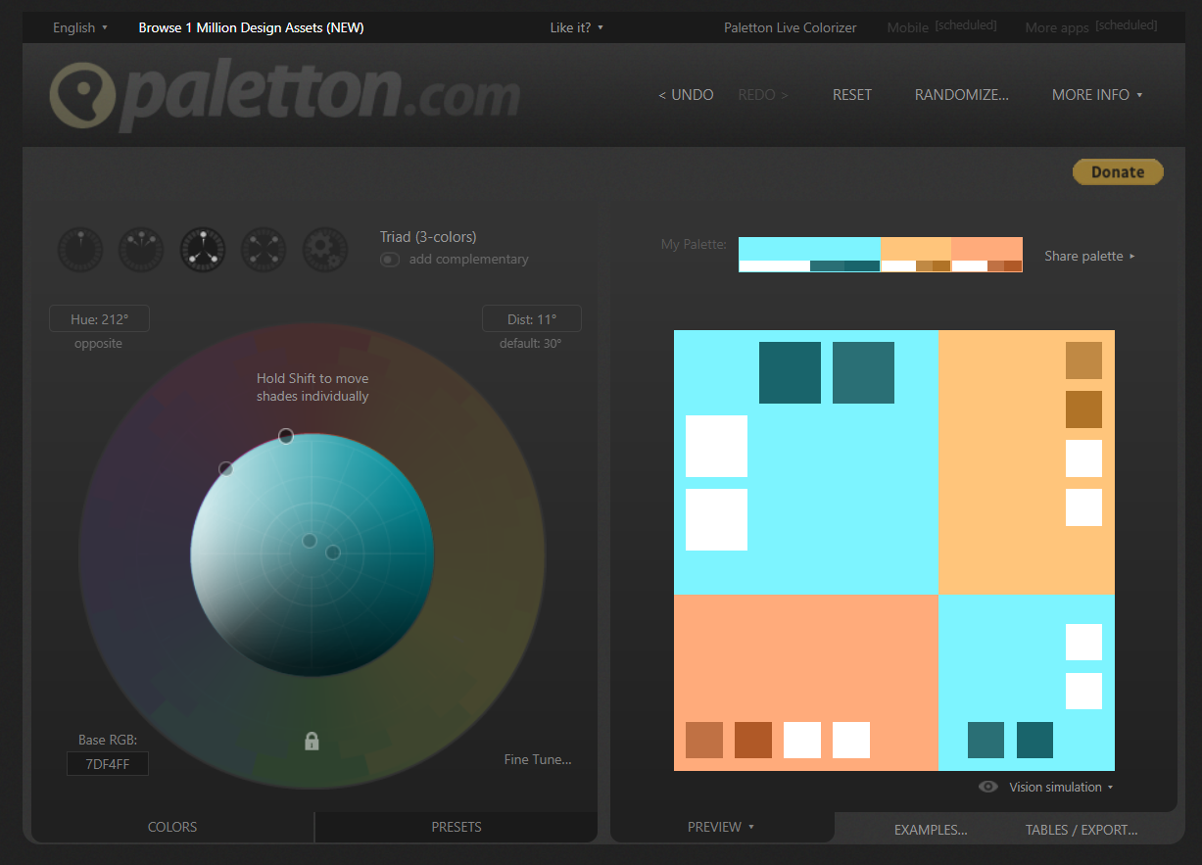

<https://paletton.com/#uid=33k0b0kgx++kFo7oPm300++00++>

<https://mdbootstrap.com/docs/jquery/css/colors/#docsTabsOverview>

#f6ea7bff ffba52ff e683a9ff